Paper Title (English) (Times Roman 14 Bold)

First Author^{1*}, Second Author ² , Last Author ³ (Times Roman 12 Bold)

¹First author Affiliation, Country (Times Roman 11: Italic)
E-mail (Times Roman 11) ORCID iD Link (https://orcid.org/)
²Second author Affiliation, Country (Times Roman 11: Italic)
E-mail (Times Roman 11) ORCID iD Link (https://orcid.org/)
³Last author Affiliation, Country (Times Roman 11: Italic)
E-mail (Times Roman 11) ORCID iD Link (https://orcid.org/)

Received: 00/00/0000
Accepted: 00/00/0000
Published: 00/00/0000

*Corresponding author:

Citation:

___________________
© 2023 Turath / Published by the Centre of Research in Social and Cultural Anthropology (CRASC), Algeria.


This is an open access article under the CC BY-NC-ND 4.0 license

ABSTRACT: This template is designed to ensure consistency in formatting and text styling for submissions to Turath Journal. All margins, column widths, line spacing, and text fonts are pre-defined and must not be altered. Please refrain from adding page numbers, headers, or footers. Once your manuscript is formatted according to these guidelines, it should resemble the template provided by the journal. The abstract should be concise and highlight the purpose and significance of the research. Avoid using symbols, special characters, footnotes, or mathematical expressions in the title or abstract. The title and abstract are crucial for effectively communicating the essence of the research, as they play a key role in ensuring the paper is discoverable and widely read. (Font: Times New Roman, Size: 12, Italic)

KEYWORDS: Include at least five keywords. (Font: Times New Roman, Size: 12, Normal, Single Line Spacing)

Titre de l’article (Français) (Times Roman 14 Bold)

RÉSUMÉ : Ce modèle est conçu pour garantir la cohérence du formatage et du style de texte pour les soumissions à la revue Turath. Toutes les marges, largeurs de colonnes, espacements de lignes et polices de texte sont prédéfinis et ne doivent pas être modifiés. Veuillez-vous abstenir d’ajouter des numéros de page, en-têtes ou pieds de page. Une fois votre manuscrit formaté conformément à ces directives, il devrait ressembler au modèle fourni par la revue. Le résumé doit être concis et mettre en avant l’objectif et l’importance de la recherche. Évitez d’utiliser des symboles, des caractères spéciaux, des notes de bas de page ou des expressions mathématiques dans le titre ou le résumé. Le titre et le résumé sont essentiels pour communiquer efficacement l’essence de la recherche, car ils jouent un rôle clé pour assurer la visibilité et la lecture de l’article. (Police : Times New Roman, Taille : 12, Italique)

MOTS-CLÉS : Incluez au moins cinq mots-clés. (Police : Times New Roman, Taille : 12, Normal, Espacement simple)

عنوان المقال (العربية) Sakkal Majalla 18 Bold

الملخص: تم تصميم هذه القالب لضمان التناسق في التنسيق وأسلوب النصوص للمقالات المقدمة إلى مجلة التراث. جميع الهوامش وعرض الأعمدة وتباعد الأسطر وخطوط النصوص محددة مسبقًا ولا يجب تعديلها. يرجى الامتناع عن إضافة أرقام الصفحات أو الترويسات أو التذييلات. بمجرد تنسيق المخطوطة وفقًا لهذه الإرشادات، يجب أن تتطابق مع القالب المقدم من المجلة. يجب أن يكون الملخص موجزًا ويبرز الهدف وأهمية البحث. تجنب استخدام الرموز أو الأحرف الخاصة أو الحواشي السفلية أو التعبيرات الرياضية في العنوان أو الملخص. يعتبر العنوان والملخص عنصرين أساسيين في إيصال جوهر البحث بشكل فعال، حيث يلعبان دورًا رئيسيًا في ضمان اكتشاف الورقة وقراءتها على نطاق واسع). الخط Sakkal Majalla 14، الحجم: 12، عادي، تباعد سطر واحد(
الكلمات المفتاحية: قم بتضمين خمس كلمات مفتاحية على الأقل) .الخط Sakkal Majalla 14، الحجم: 12، عادي، تباعد سطر واحد(

Introduction
The first line of the opening paragraph in each section should not be indented, whereas subsequent paragraphs must have a 1 cm indentation. Manuscripts may be submitted in Arabic, English and French. Authors must ensure their work is carefully proofread for spelling and grammatical accuracy prior to submission. The entire manuscript should be formatted in Times New Roman font, size 12, with justified alignment and single-line spacing.

Document Format
Manuscripts must be prepared on A4-sized paper and submitted in Microsoft Word format (.doc or .docx) through the ASJP platform.

Paper Structure
The paper should include the following elements in order:
- Title of the paper.
- Authors' names and affiliations.
- Abstract and keywords.
- Main body (including figures and tables).
- Results and discussions.
- Conclusions.
- References.
Ensure that no text, tables, or figures extend beyond the page margins.

Figures and Tables
Figures and tables should be embedded within the text and placed near their first mention. Each figure or table must be numbered sequentially and centered. Table headings should appear below the tables, while figure captions should be placed underneath the figures. Both captions and headings must be clear and provide sufficient information to understand the content without referring to the main text. Avoid including tables or figures that are not cited in the text.

Example of Table and Figure Formatting

Table 1. Title of the Table

Example column 1 | Example column 2 | Example column 3

Figure 1. Title of Figure 1
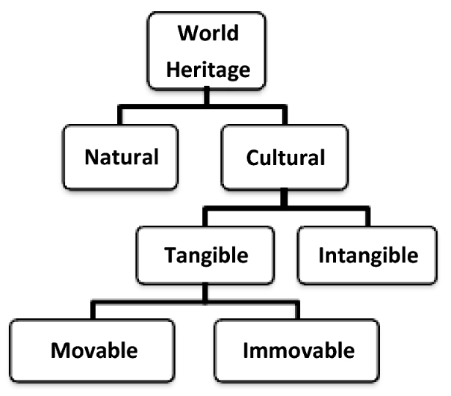

Conclusions
Adherence to these guidelines is crucial for manuscript acceptance. Submissions that do not meet the formatting requirements will be returned for revision.

Acknowledgments (Optional)
Acknowledgments, if any, should appear before the references section and must not be numbered.

References
References should be listed alphabetically by the author's last name and formatted in APA 7th edition. Citations in the text must include the author's last name, year of publication, and page number (e.g., Weinstein, 2009, p. 25). The reference list must only include works cited in the manuscript and vice versa. A minimum of 20 high-quality references is recommended. Examples are provided below:

Books
- Wells, A. (2009). Metacognitive therapy for anxiety and depression in psychology. Guilford Press.
- Colclough, B., & Colclough, J. (1999). A challenge to change. Thorsons.
Book Chapters
- Payne, S. (1999). 'Dangerous and different': Reconstructions of madness in the 1990s and the role of mental health policy. In S. Watson & L. Doyal (Eds.), Engendering social policy (pp. 180–195). Open University Press.

Journal Articles
- Kyratsis, A. (2004). Talk and interaction among children and the co-construction of peer groups and peer culture. Annual Review of Anthropology, 33(4), 231–247.
Theses
- Ryan, J. (2014). The measurement and meaning of coping in psychiatric patients [PhD thesis, Murdoch University]. Murdoch University Research Repository.
Videos
- NRK. (2007, February 26). Medieval helpdesk with English subtitles [Video]. http://www.youtube.com/watch?v=pQHX-SjgQvQ

Authors’ Biographies (in English)
Biographical statements must include the author’s full name, qualifications, institutional affiliations, and positions of responsibility. Authors may also include relevant personal history or academic program details. Biographies should not exceed 100 words.

